**Indira Gandhi Delhi Technical University for Women**

**(Established by Govt. of Delhi vide Act 09 of 2012)**

# (Formerly Indira Gandhi Institute of Technology) Kashmere Gate, Delhi - 110006



**LABORATORY FILE**

**for**

**Web Technologies**

**MCA 207**

**Submitted by:**

**Submitted to:**

Ms. Ankita Singh Roopal Mittal

MCA, 3rd Sem 02004092019

**Date: 20-08-2020 LAB 3 WORK**

**Ques 4: Develop a HTML page which has used inline and internal type CSS.**

**HTML Code:**

<!DOCTYPE html>

<html lang="en">

<head>

<title> Login Page </title>

<style> h1 {

color: white;

} button {

background-color: #33FF38 ;

}

.container { padding: 40px; width: 300px;

background-color: #F9FF33 ;

}

</style>

</head>

<body bgcolor="#0F044F">

<center> <h1><u> Student Login Form </u></h1>

<form >

<div class="container">

<label>Login ID : </label>

<input type="text" placeholder="Enter Username" name="username" required>

<br><br>

<label>Password : </label>

<input type="password" placeholder="Enter Password" name="password" required>

<br>

<input type="checkbox" checked="checked"> Remember me

<br><br>

<button type="submit">Submit</button>

<button type="button" class="cancelbtn"> Reset </button>

<br><a href=" "> Forgot password? </a>

</div>

</form>

</center>

</body>

</html>

**OUTPUT Webpage:**

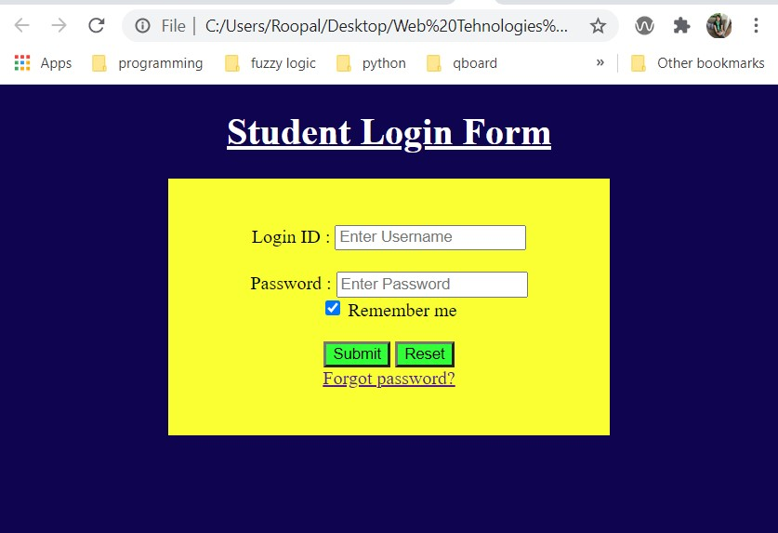

**Ques 5: Develop a HTML page and external CSS file and link the external CSS file with HTML**

**HTML Code:**

<!DOCTYPE html>

<html lang='en'>

<head>

<meta charset="utf-8">

<link href="Ques 5.css" rel="stylesheet">

<title>Student Registeration </title>

</head>

<body bgcolor="black" text="black">

<form>

<div class="container">

<center> <font color= "black"> <h1> Student Registeration Form <font></h1> </center>

<hr>

<label> Firstname </label>

<input type="text" name="firstname" placeholder= "Firstname" size="15" required />

<label> Middlename: </label>

<input type="text" name="middlename" placeholder="Middlename" size="15" required />

<label> Lastname: </label>

<input type="text" name="lastname" placeholder="Lastname" size="15"required />

<div> <label>

Course :

</label>

<select>

<option value="Course">Course</option>

<option value="BCA">BCA</option>

<option value="BBA">BBA</option>

<option value="B.Tech">B.Tech</option>

<option value="MBA">MBA</option>

<option value="MCA">MCA</option>

<option value="M.Tech">M.Tech</option>

</select>

</div>

<div>

<label> Gender :

</label><br>

<input type="radio" value="Male" name="gender" checked > Male

<input type="radio" value="Female" name="gender"> Female

<input type="radio" value="Other" name="gender"> Other

</div>

<label> Phone :

</label>

<input type="text" name="country code" placeholder="Country Code" value="+91" size="2"/>

<input type="text" name="phone" placeholder="phone no." size="10"/ required> Current Address :

<textarea cols="80" rows="5" placeholder="Current Address" value="address" required> </textarea>

<label for="email"><b>Email</b></label>

<input type="text" placeholder="Enter Email" name="email" required>

<label for="psw"><b>Password</b></label>

<input type="password" placeholder="Enter Password" name="psw" required>

<label for="psw-repeat"><b>Re-type Password</b></label>

<input type="password" placeholder="Retype Password" name="psw-repeat" required>

<button type="submit" class="registerbtn">Register</button>

</form>

</body>

</html>

**CSS Code:**

.container { padding: 50px; align: center;

background-color: lightblue;

}

input[type=text], input[type=password], textarea { width: 100%; padding: 15px; margin: 5px 0 22px 0; display: inline-block;

background: #f1f1f1;

}

input[type=text]: focus, input[type=password]: focus { background-color: pink; outline: none;

} div {

padding: 10px 0;

} hr { border: 1px solid #f1f1f1;

margin-bottom: 25px;

}

.registerbtn { background-color: #4CAF50; color: white; padding: 16px 20px;

width: 100%;

}

**OUTPUT Webpage:**

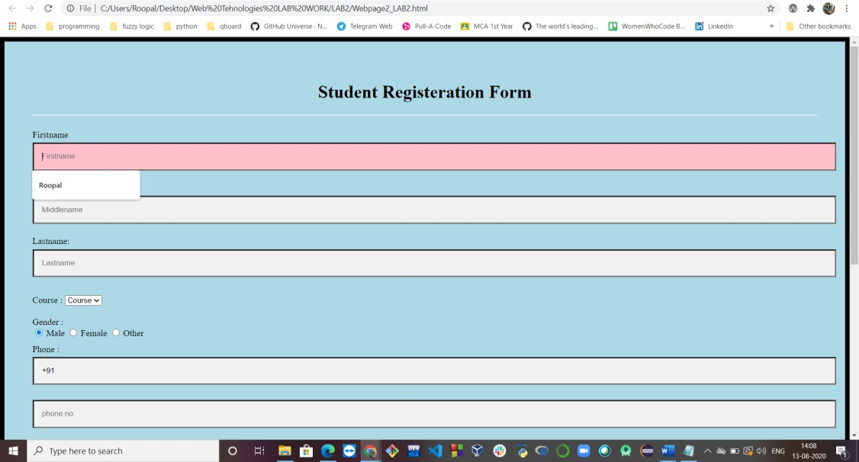

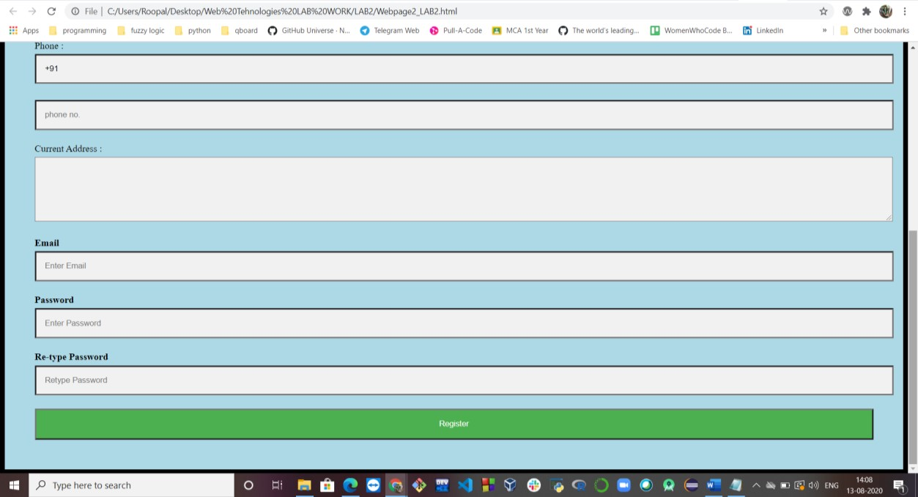

**Ques 6: Create your resume using HTML and CSS.**

**HTML Code:**

<html>

<head>

<meta charset="utf-8">

<link href="Ques 6.css" rel="stylesheet">

<title>

My portfolio

</title>

</head>

<body>

<div class="row">

<div class="column">

<div class="content">

<img src="dp2.jpg" alt="dp.jpeg" style="width:45%">

<h1>ROOPAL MITTAL</h1>

<p> roopal020mca19@igdtuw.ac.in</p>



<p> +91 8588910428</p>

<p> F-18/44, Sector -15

Rohini, Delhi-110089

India</p><br>

<h2>Interests</h2>

<p>Travelling</p>

<p>Teaching</p>

<p>Smart Technologies</p>

<p>Adventure sports</p><br>

<h2>Reference</h2>

Dr. Dhanpal Singh-"Keshav Mahavidyalaya, University of

Delhi",Professor<br><br>

E-mail: drdpkmv@gmail.com<br><br>

Phone: 9811447977

</div>

</div>

<div class="column">

<div class="content">

<h2>Career Objective</h2>

Aiming to pursue technical career, where growth is synonym to challenging task that pushes me out of my comfort zone to acquire wisdom. Driven to work hard, meet strict headlines and reach new heights. Seeking to apply my strategic skills to prove to be an asset for the organisation.

</div>

</div>

<div class="column">

<div class="content">

<h2>Education</h2>

 Indira Gandhi Delhi Technical University, Delhi,

MCA (2019-22) (7.92 SGPA) <br><br>

 Keshav Mahavidyalaya, University of Delhi,

B.Sc.(H)Mathematics(2016-19) (8.608

CGPA)<br><br>

 D.A.V. Public School, Pushpanjali Enclave, Delhi,

Higher Secondary School (2015-16) (92.5%)<br><br> Rockfield Public School, Rohini, Delhi, Senior

Secondary School (2013-14) (10 CGPA)

</div>

</div>

<div class="column">

<div class="content">

<h2>Achievements and Extra-Curricular Activities</h2> <ol>

<li>Coordinator in a rally organised by Rotaract Club of Sri

Aurobindo College in February, 2018.</li><br>

<li>Member, Rotaract Club of Visioners League for the Rota year 2017-18, won Rotaractor of the year award.</li><br>

<li>Campus ambassador, ELOQUENCE'17 and CORONA'18

(Annual literary and cultural fest of Bhagwan Parshuram Institute of Technology,Delhi respectively.)</li><br>

<li>Senior- Executive, Department of Mathematics, Keshav

Mahavidyalaya (2016-2017), Organiser of

MODULUS'17.</li><br>

<li>Won many state and zonal level competitions in judo and archery.

</ol>

</div>

</div>

<div class="column">

<div class="content">

<h2>Skills and Competences</h2>

<ul type="disc">

<li> Well Versed at Microsoft Office Application,

Mathematica software</li>

<li> Intermediate at MySQL,Latex</li>

<li> Programming Languages : C/C++, HTML,R</li>

<li> Others: Motivator |Fast learner|Technical and analytical mind</li><br>

</ul>

<h2>Personal Profile</h2>

<ul type="square">

<li>Father's Name : Mr. Alok Mittal</li>

<li>Mother's Name : Mrs. Anita Mittal</li>

<li>Nationality : Indian</li>

<li>Date of Birth : 03/04/1999</li>

<li>Languages known : English, Hindi</li>

</ul>

</div>

</div>

</div>

</body>

</html>

**CSS Code:**

html {

font-family: "georgia", sans-serif;

} h1 { margin: 0; padding: 20px 0; color: #C11B17;

} h2 { margin: 0; padding: 20px 0; color: #151B54;

} p { width: 500px;

}

body{

background-color: #E5E4E2;

color:black; border-style: solid;

} img { display: block; align: left;

width: 200px;

}

.column {

float: left;

width: 27%;

}

/* Add padding BETWEEN each column */

.row, .row > .column {

padding: 30px;

}

/* Clear floats after rows */

.row:after { content: ""; display: table;

clear: both;

}

**OUTPUT Webpage:**

